Assignment 1: Automated S3 Bucket Cleanup Using AWS Lambda and Boto3
Concept Diagram
User
│
▼
AWS Lambda
│
│ Uses IAM Role
▼
IAM Role (AmazonS3FullAccess)
│
▼
Amazon S3 Bucket
│
▼
Deletes files older than 30 days

Step 1: S3 Setup
- Open the **Amazon S3 console.
- Click Create bucket.
- Uploaded several files to the bucket, Ensuring that some files will be deleted after test.

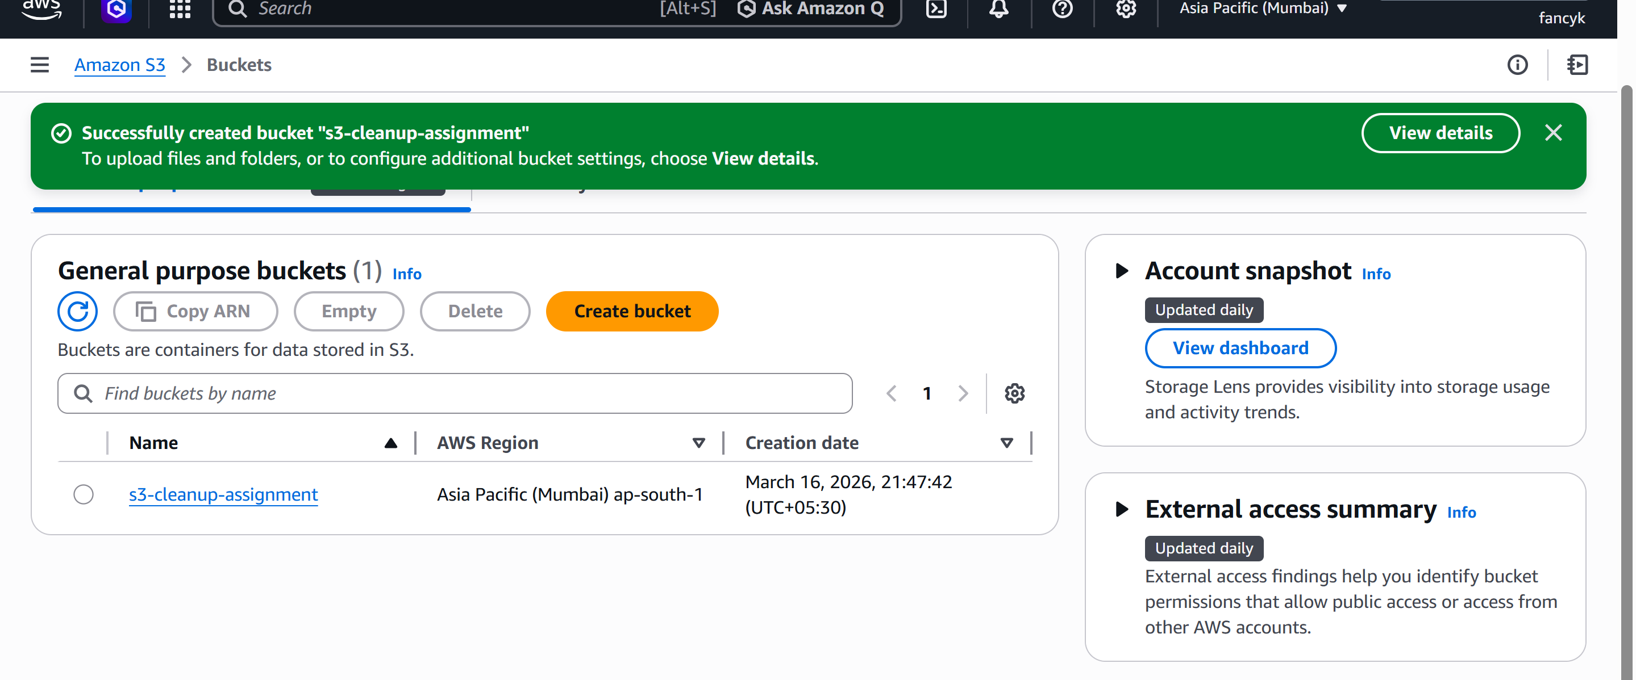
Upload Files for testing purpose
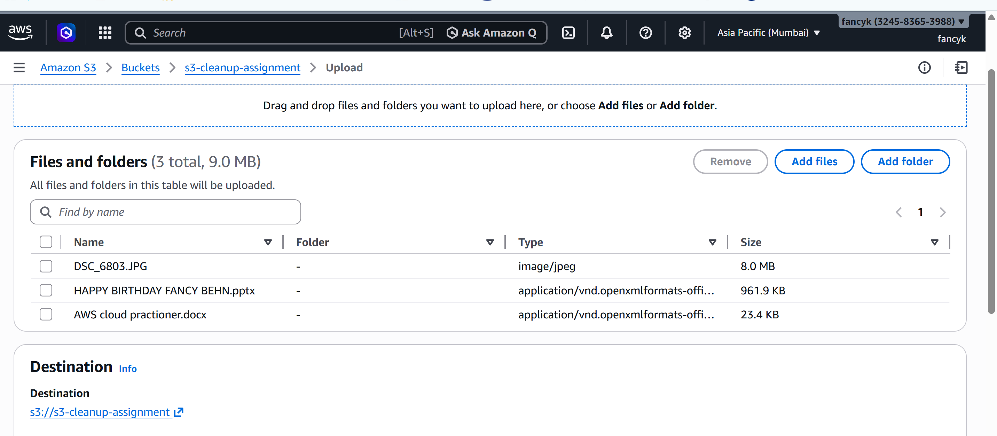

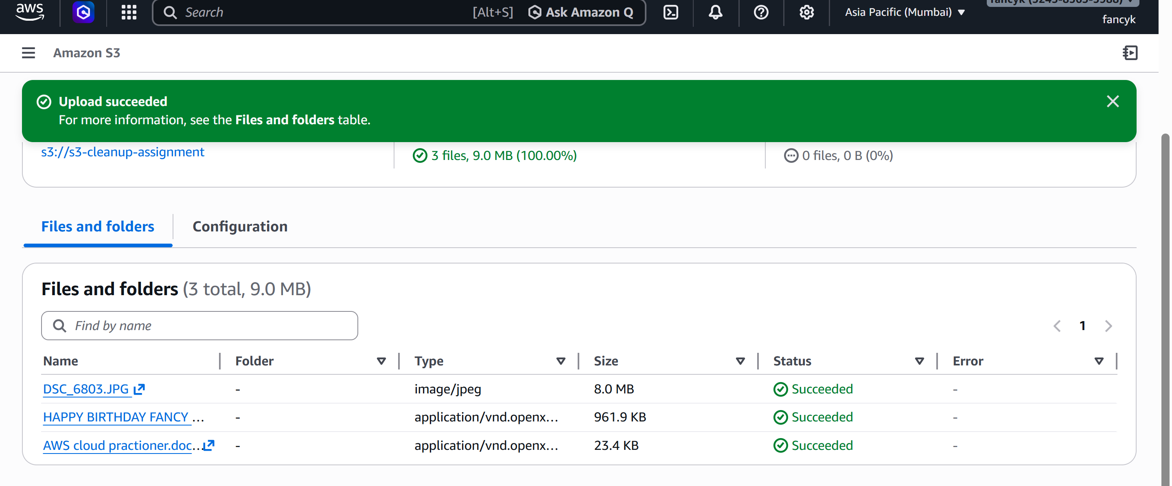
Step 2: Create IAM Role for Lambda
- Open the **AWS Identity and Access Management console.
- Click Roles → Create Role.
- Choose AWS Service → Lambda.
- Attach the policy:

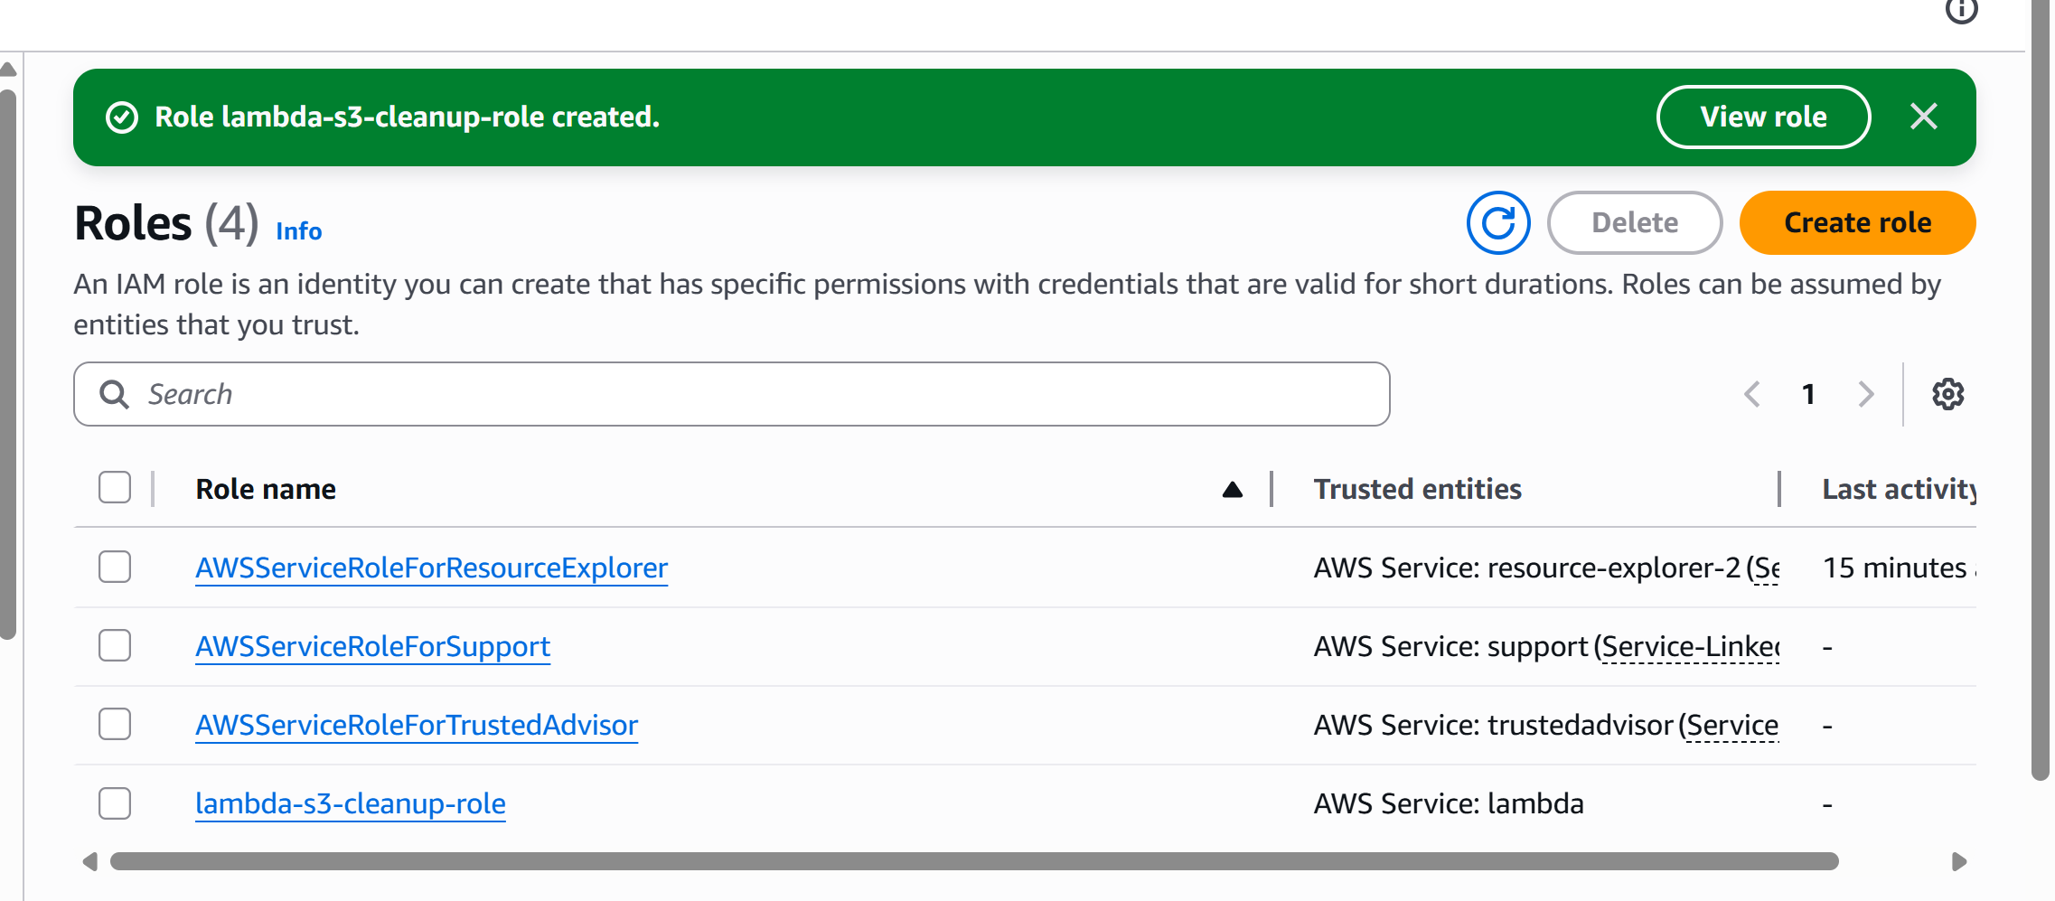
Step 3: Create Lambda Function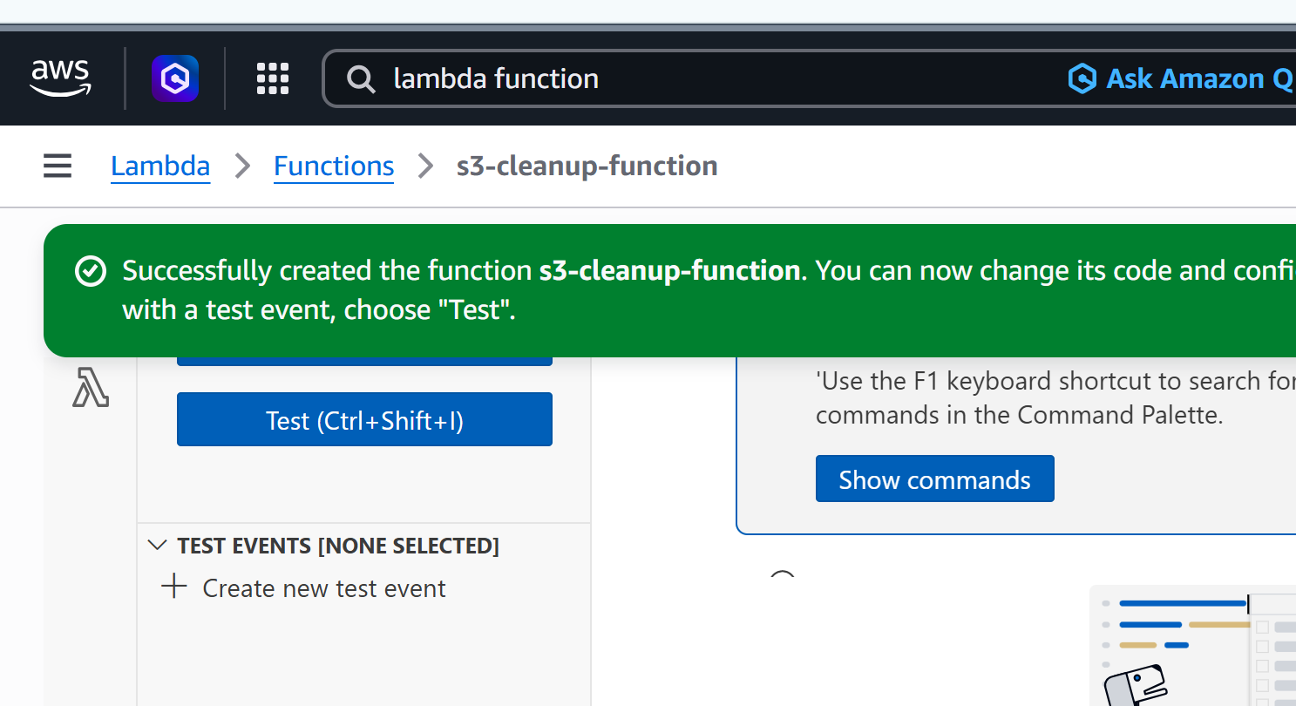
Step 4: Lambda Python Code (Boto3)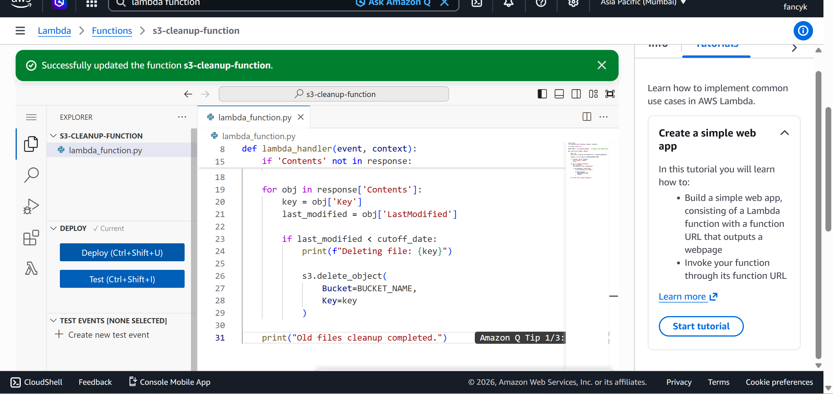

Step 5: Created Test Event for output
After Writing the Code
1️⃣ Click Deploy
2️⃣ Click Test
3️⃣ Create test event:

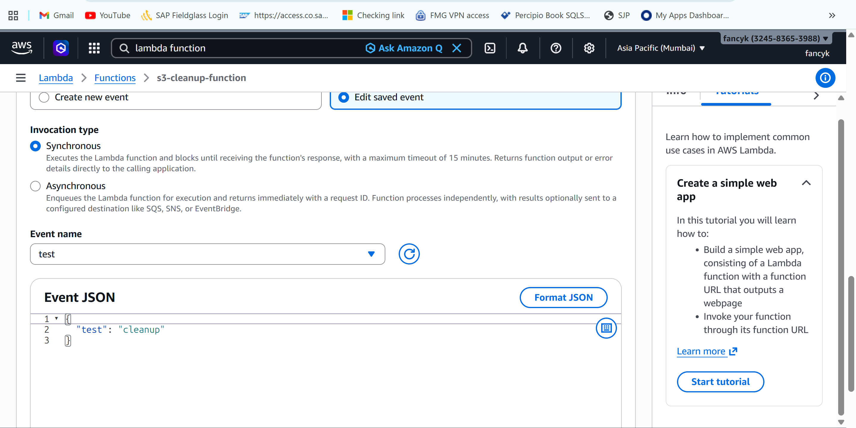
Expected Log Output
In Amazon CloudWatch logs we observed
